ACCOUNT MICROSERVICES

package com.cognizant.account;  
  
import org.springframework.boot.SpringApplication;  
import org.springframework.boot.autoconfigure.SpringBootApplication;  
  
@SpringBootApplication  
public class AccountApplication {  
  
 public static void main(String[] args) {  
 SpringApplication.*run*(AccountApplication.class, args);  
 }  
  
}

package com.cognizant.account;  
  
import org.springframework.web.bind.annotation.\*;  
  
@RestController  
@RequestMapping("/accounts")  
public class AccountController {  
  
 @GetMapping("/{number}")  
 public Account getAccount(@PathVariable String number) {  
 return new Account(number, "savings", 234343);  
 }  
  
 static class Account {  
 public String number;  
 public String type;  
 public double balance;  
  
 public Account(String number, String type, double balance) {  
 this.number = number;  
 this.type = type;  
 this.balance = balance;  
 }  
 }  
}

OUTPUT:

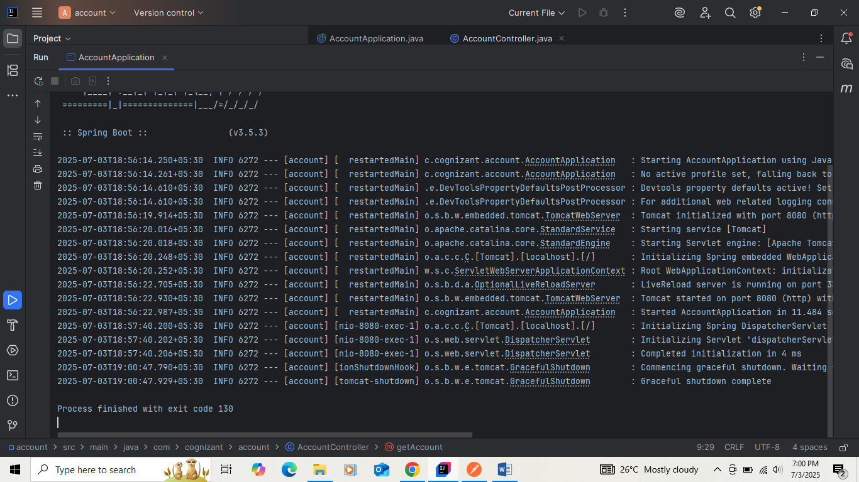

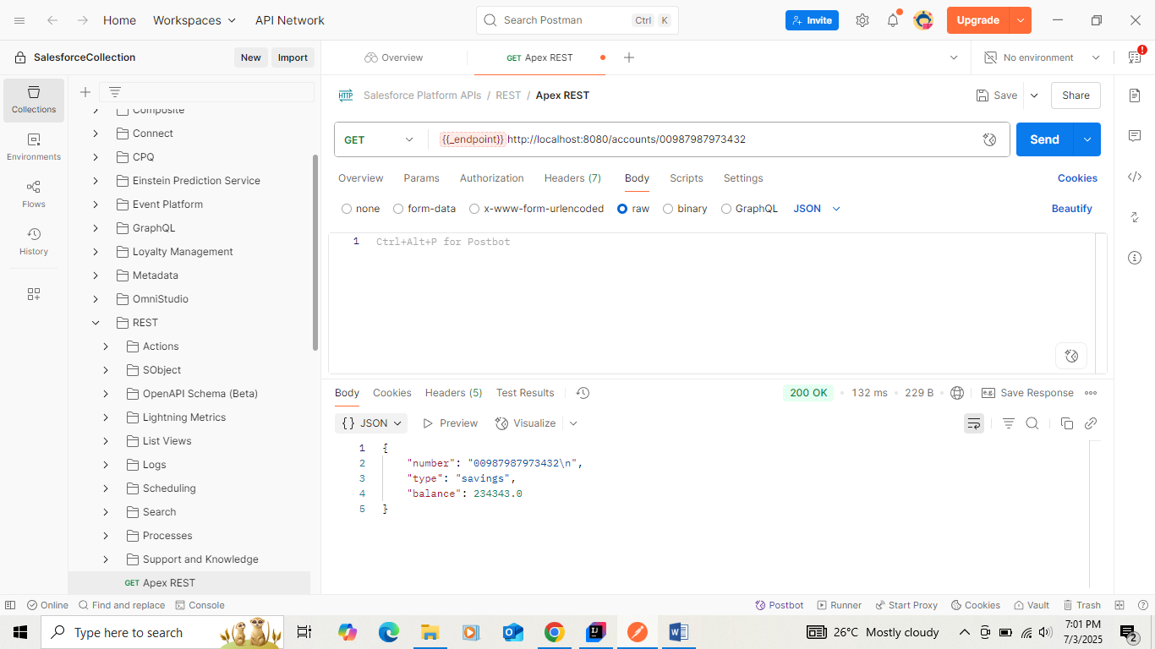

LOAN MICROSERVICES

package com.cognizant.loan;  
  
import org.springframework.boot.SpringApplication;  
import org.springframework.boot.autoconfigure.SpringBootApplication;  
  
@SpringBootApplication  
public class LoanApplication {  
  
 public static void main(String[] args) {  
 SpringApplication.*run*(LoanApplication.class, args);  
 }  
  
}

package com.cognizant.loan;  
  
import org.springframework.web.bind.annotation.\*;  
  
@RestController  
@RequestMapping("/loans")  
public class LoanController {  
  
 @GetMapping("/{number}")  
 public Loan getLoan(@PathVariable String number) {  
 return new Loan(number, "car", 400000, 3258, 18);  
 }  
  
 static class Loan {  
 public String number;  
 public String type;  
 public double loan;  
 public double emi;  
 public int tenure;  
  
 public Loan(String number, String type, double loan, double emi, int tenure) {  
 this.number = number;  
 this.type = type;  
 this.loan = loan;  
 this.emi = emi;  
 this.tenure = tenure;  
 }  
 }  
}

OUTPUT:

